



SITAM
SATYA INSTITUTE OF TECHNOLOGY AND MANAGEMENT
Near RTO Office, Gajularega, Vizianagaram-535003, Andhra Pradesh, India
Accredited by "NAAC", Approved by AICTE, New Delhi
(Permanently Affiliated to JNTUGV, Vizianagaram, Recognized by SBTET, Government of A.P)
Email: principal@sitam.co.in, Website: www.sitam.co.in, Face Book: /Sitam.Sgvp, Instagram:/sitamvzm
Telephone No:9676788811, 8978812341/2
EAMCET CODE: SGVP JNTUGV CODE: B6 SBTET CODE: 649
DEPARTMENT OF MECHANICAL ENGINEERING

4.1.3 Number of Classrooms and Seminar Halls With ICT- Enabled Facilities Such as Smart Class, LMS, Etc.
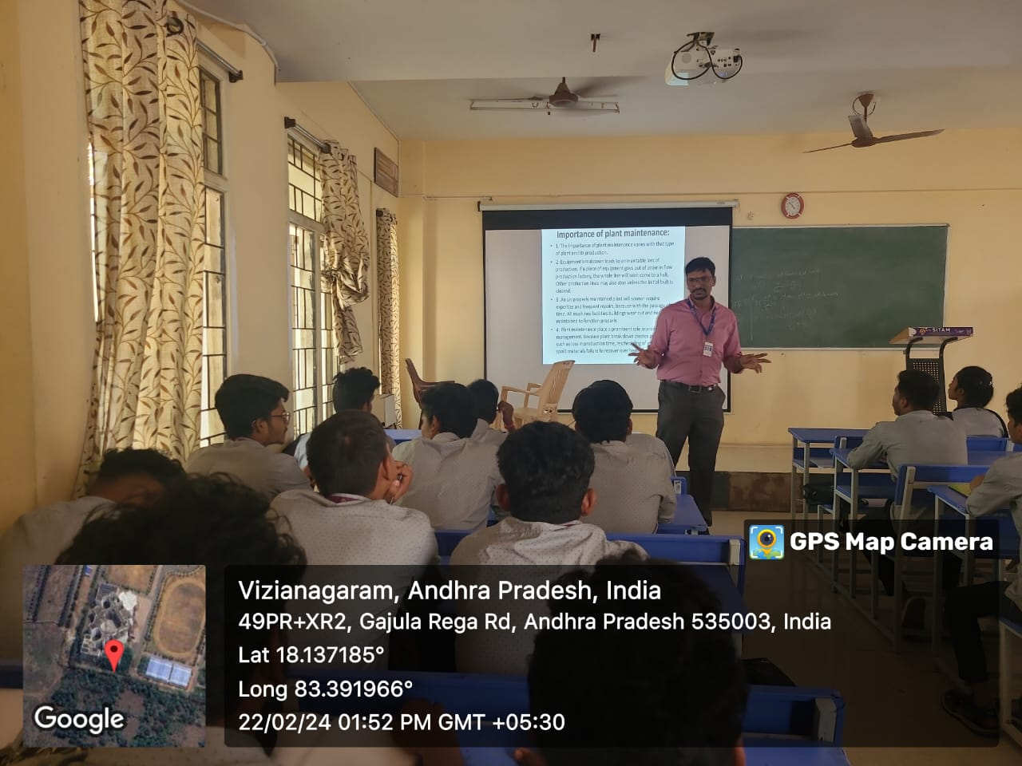
MECH CLASS ROOM A 201
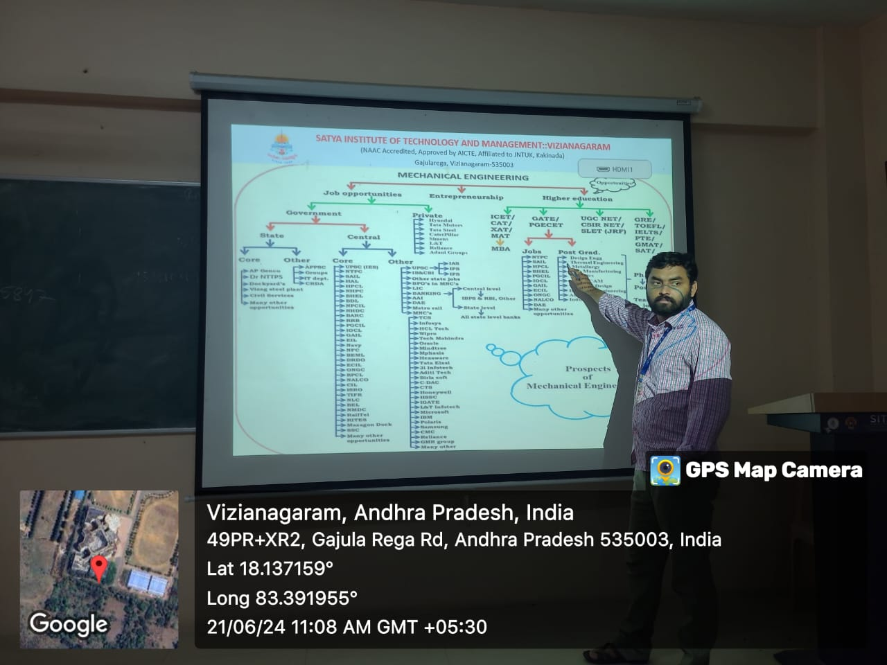
MECH CLASS ROOM A 203
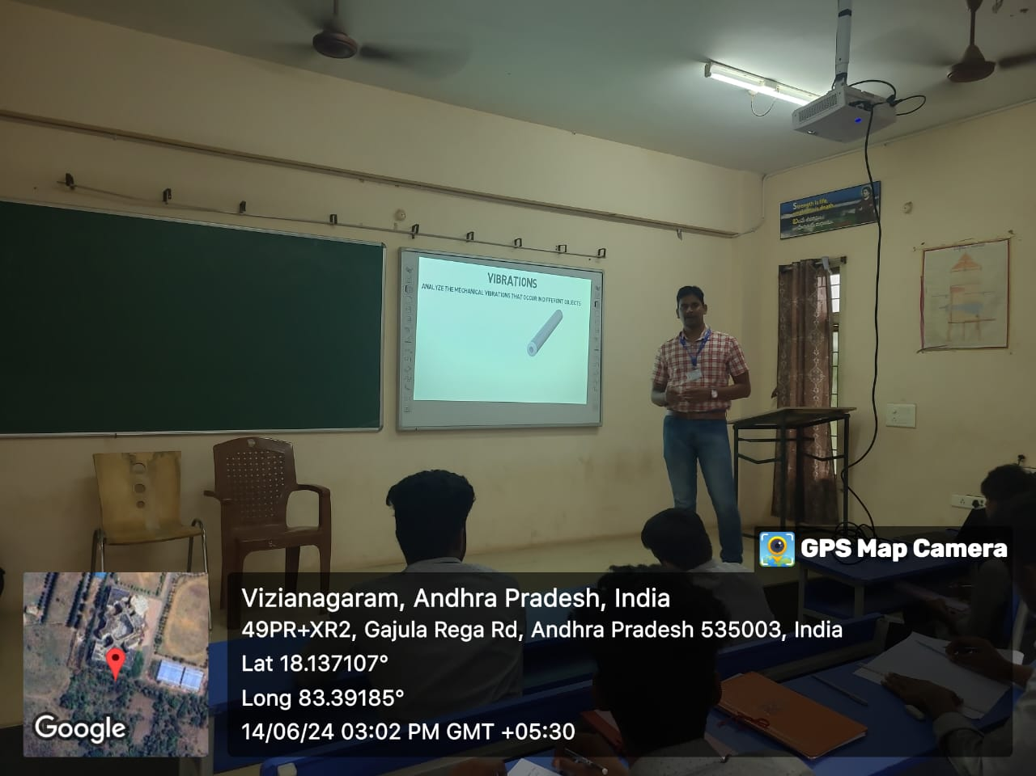
MECH CLASS ROOM A 205

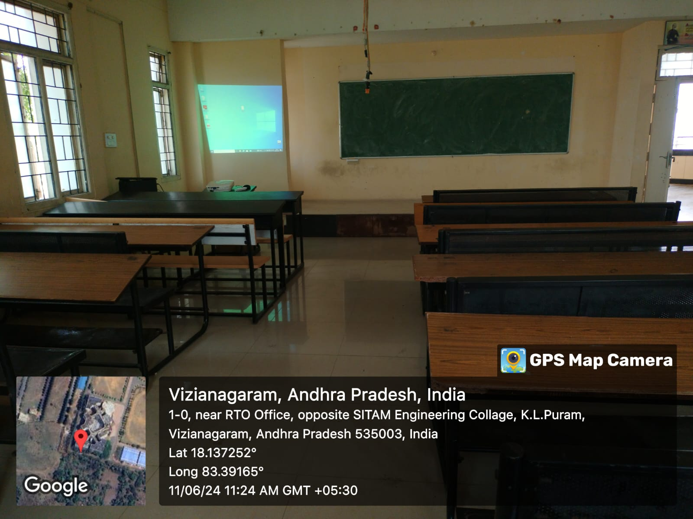
CIVIL CLASS ROOM B 203
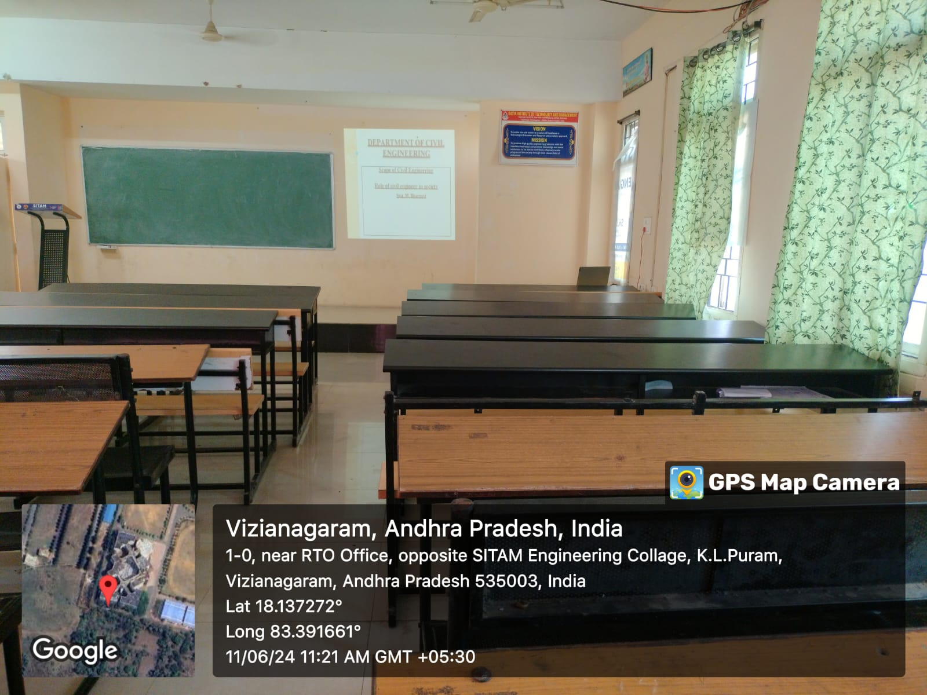
CIVIL CLASS ROOM B 205
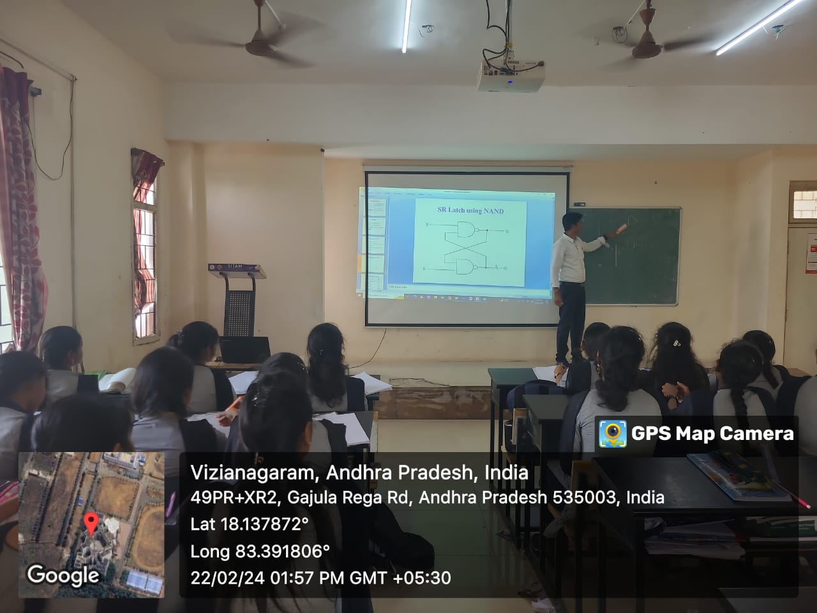
ECE CLASS ROOM D 203
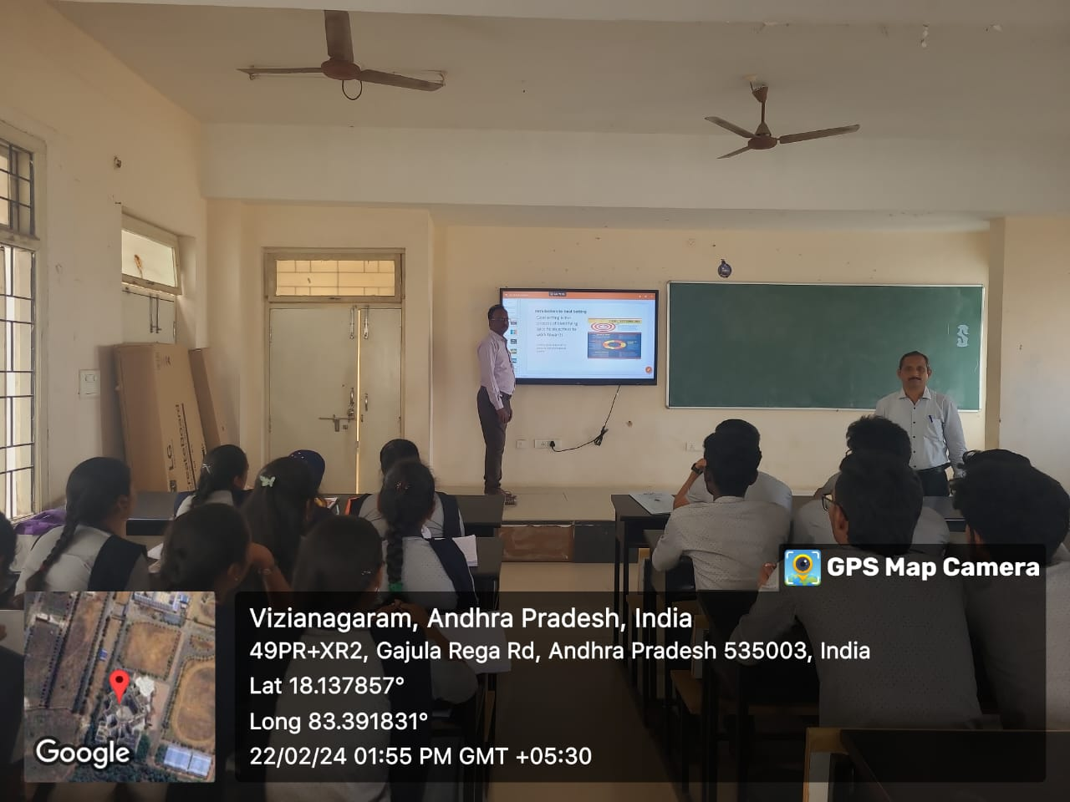
ECE CLASS ROOM D 205

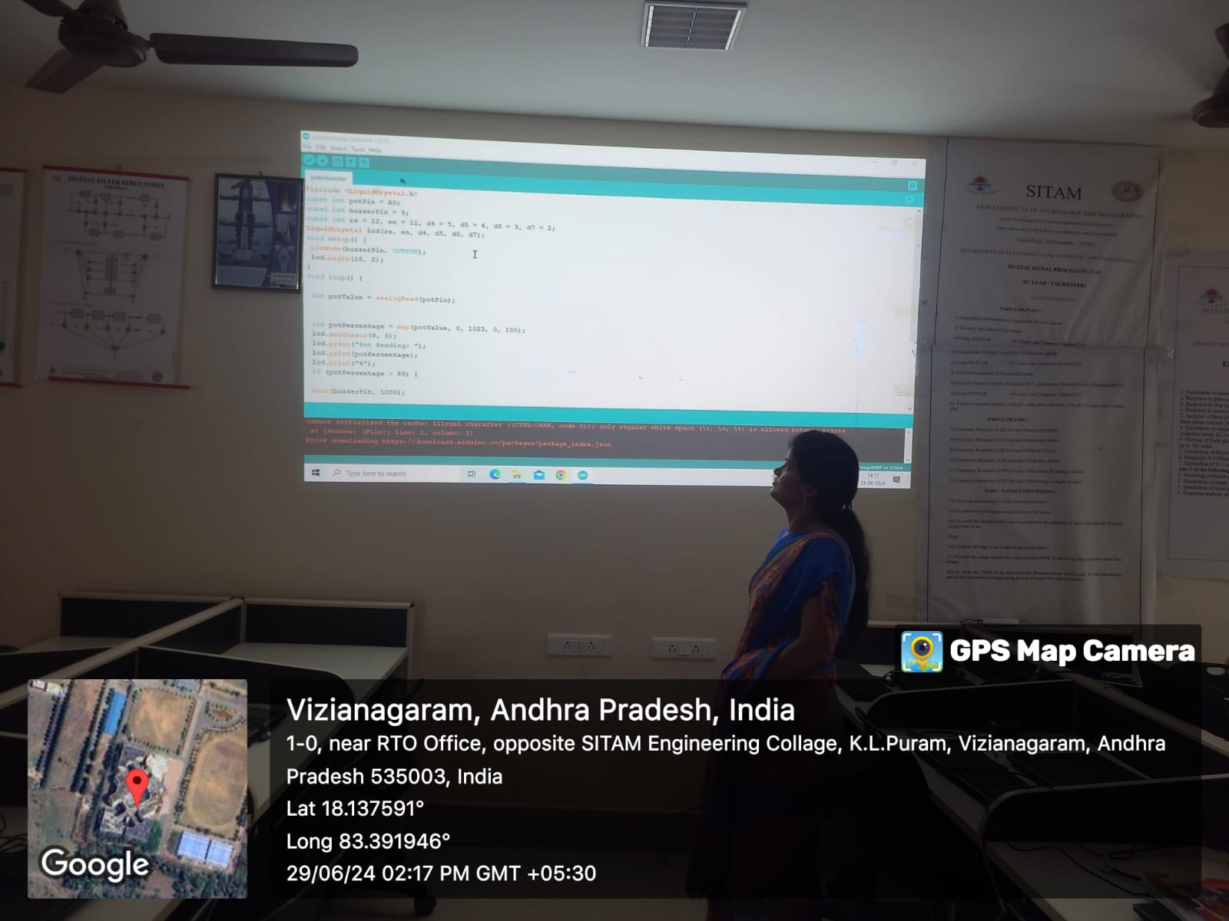
ECE SIMULATION LAB F 201
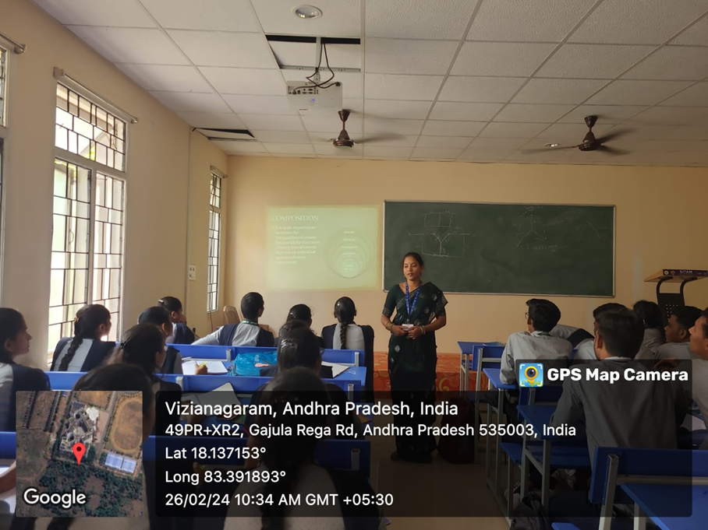
H&BS CLASS ROOM A 302

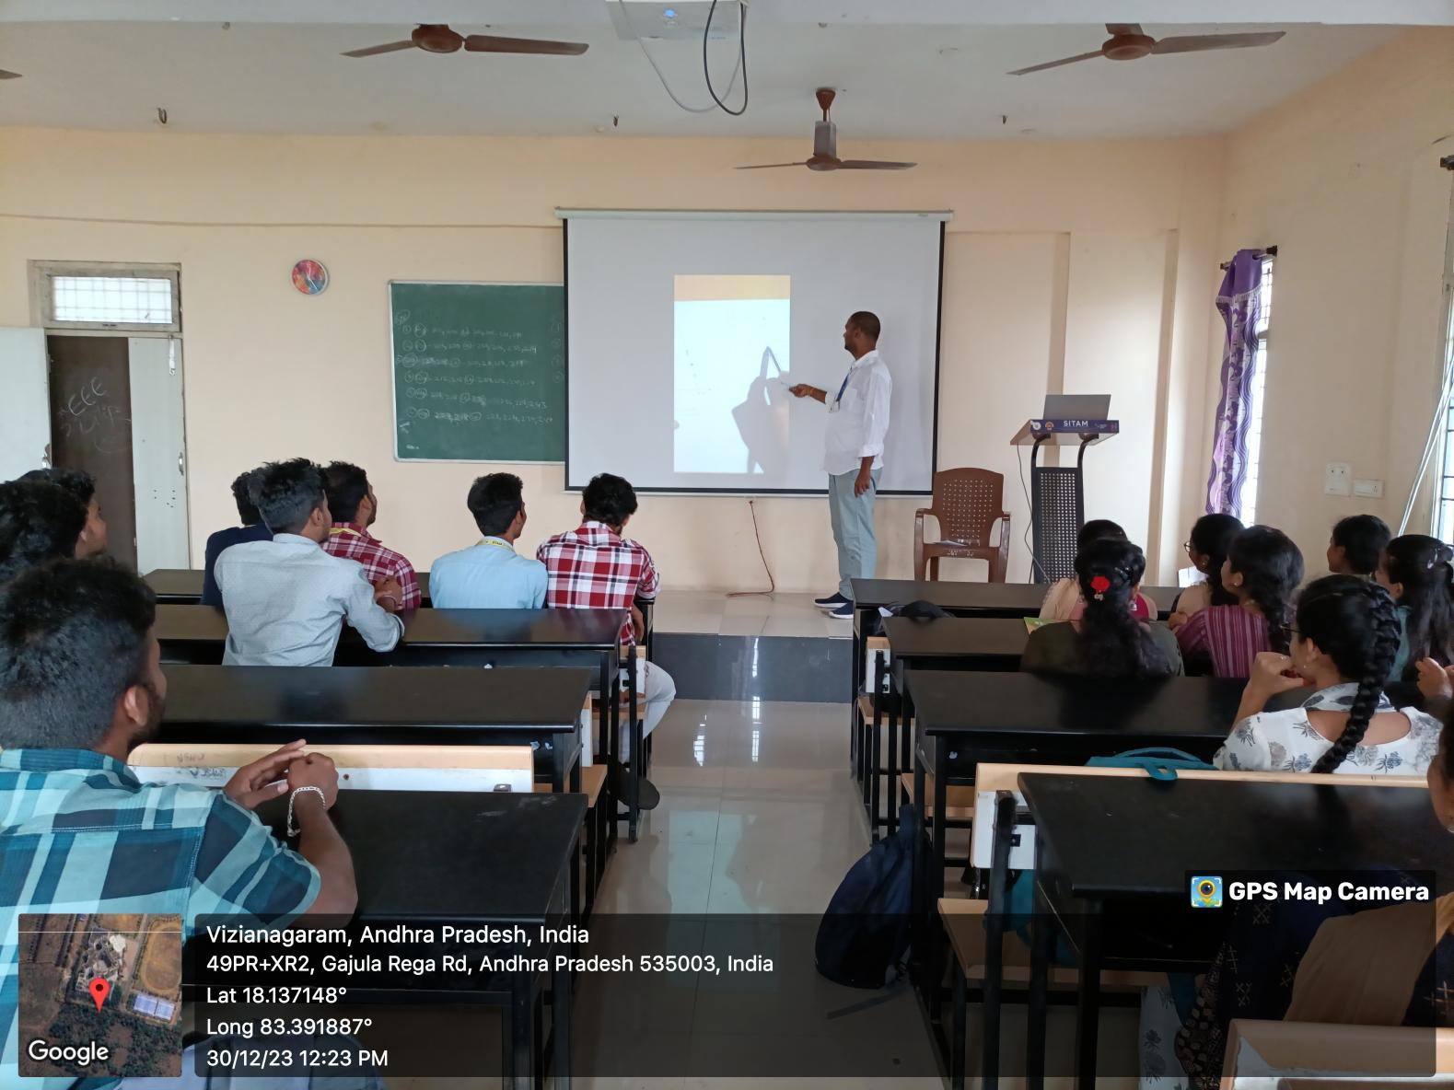
H&BS CLASS ROOM A 305
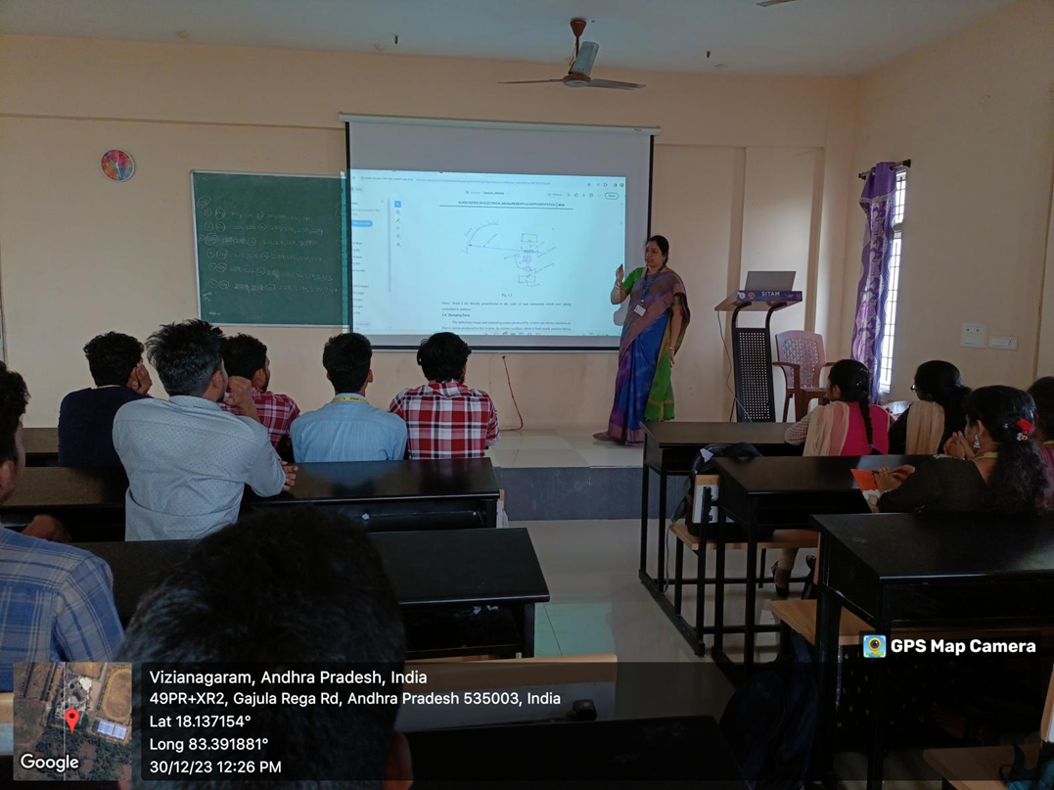
EEE CLASS ROOM A 403

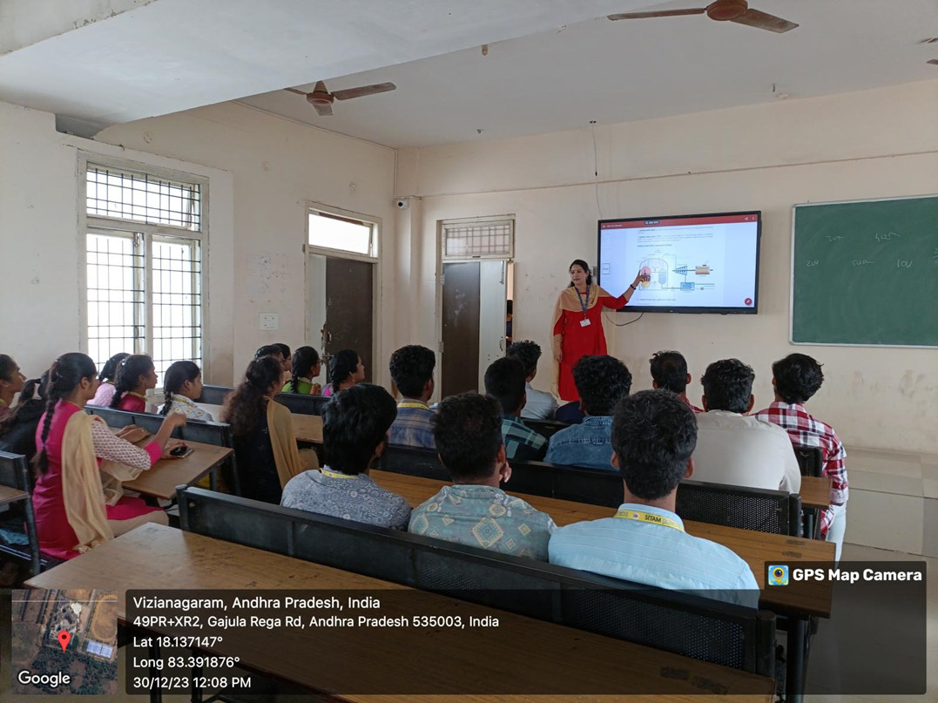
EEE CLASS ROOM A 405
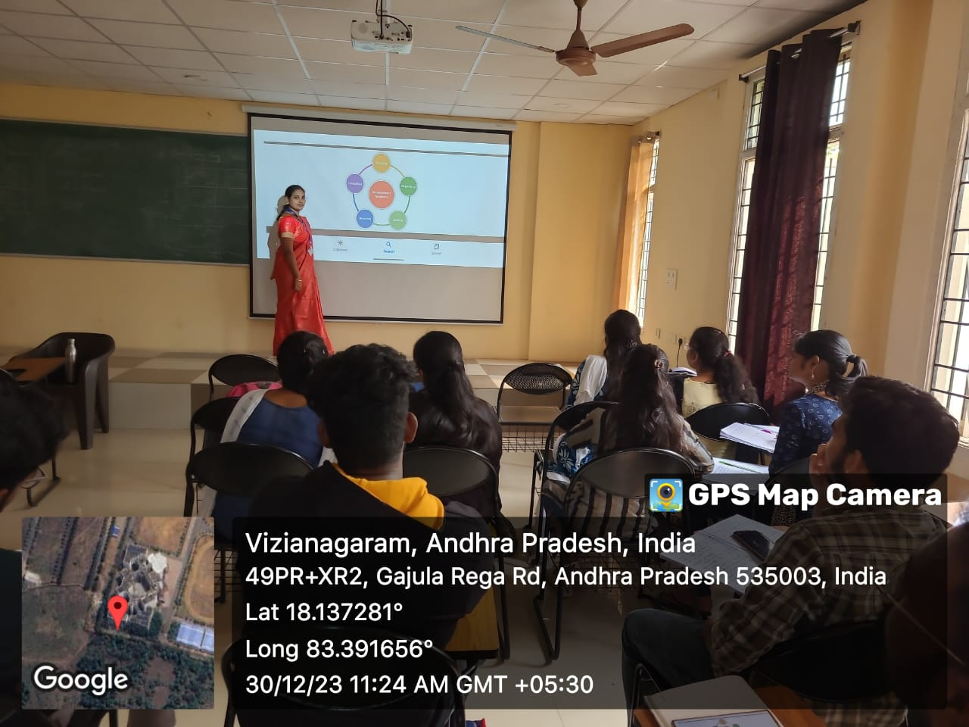
MBA CLASS ROOM B 403

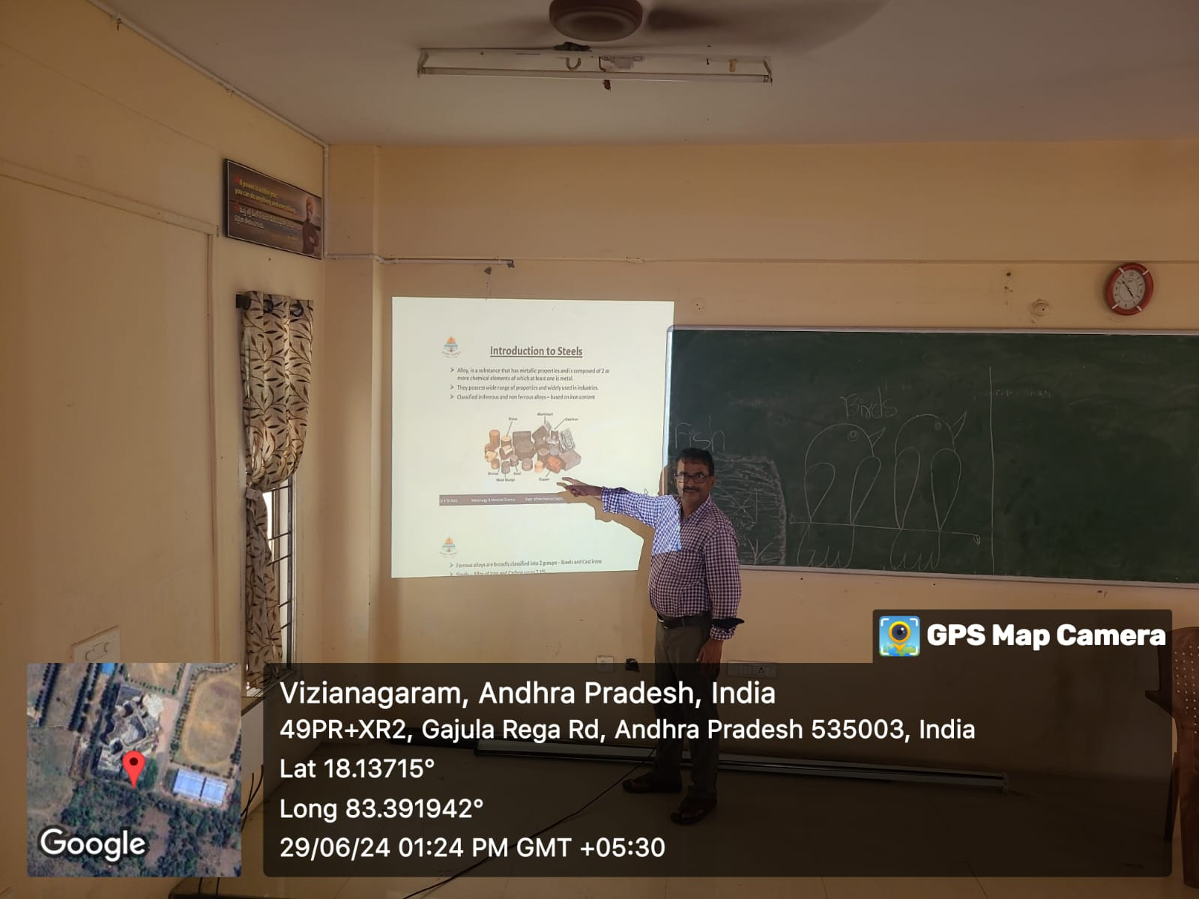
H&BS CLASS ROOM B 305
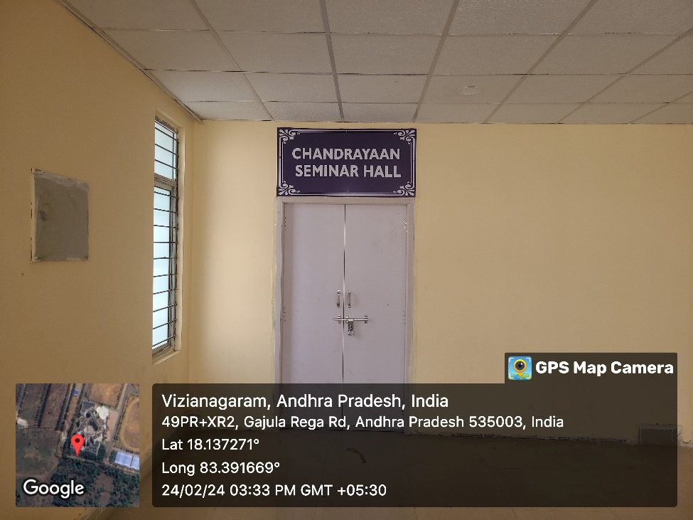
CHANDRAYAAN SEMINAR HALL
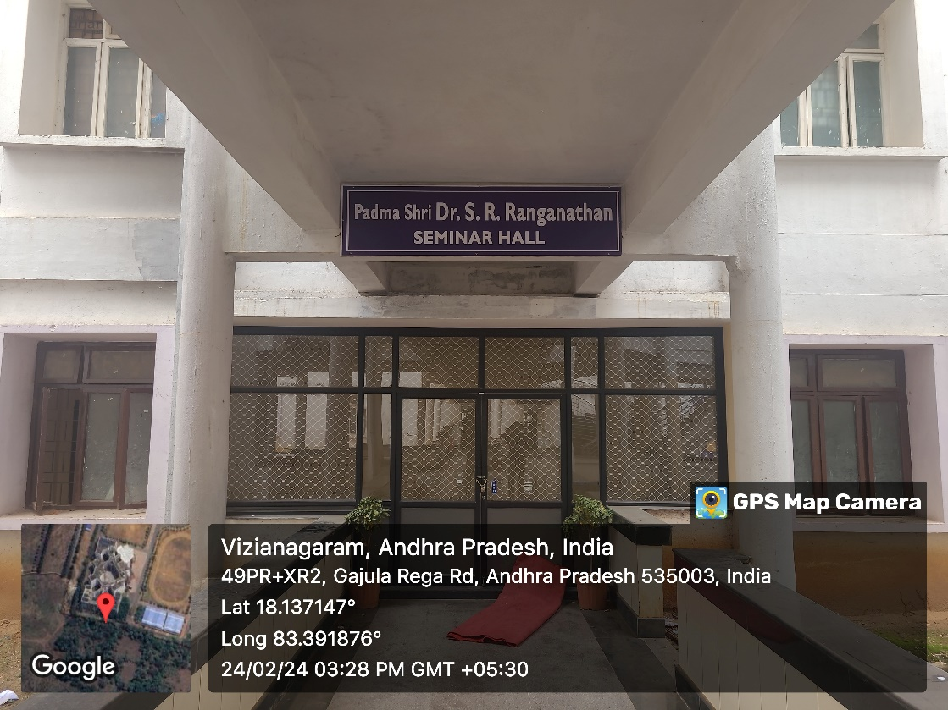
Padma shri Dr. S. R. Ranganathan seminar hall
ECE SIMULATION LAB F 201

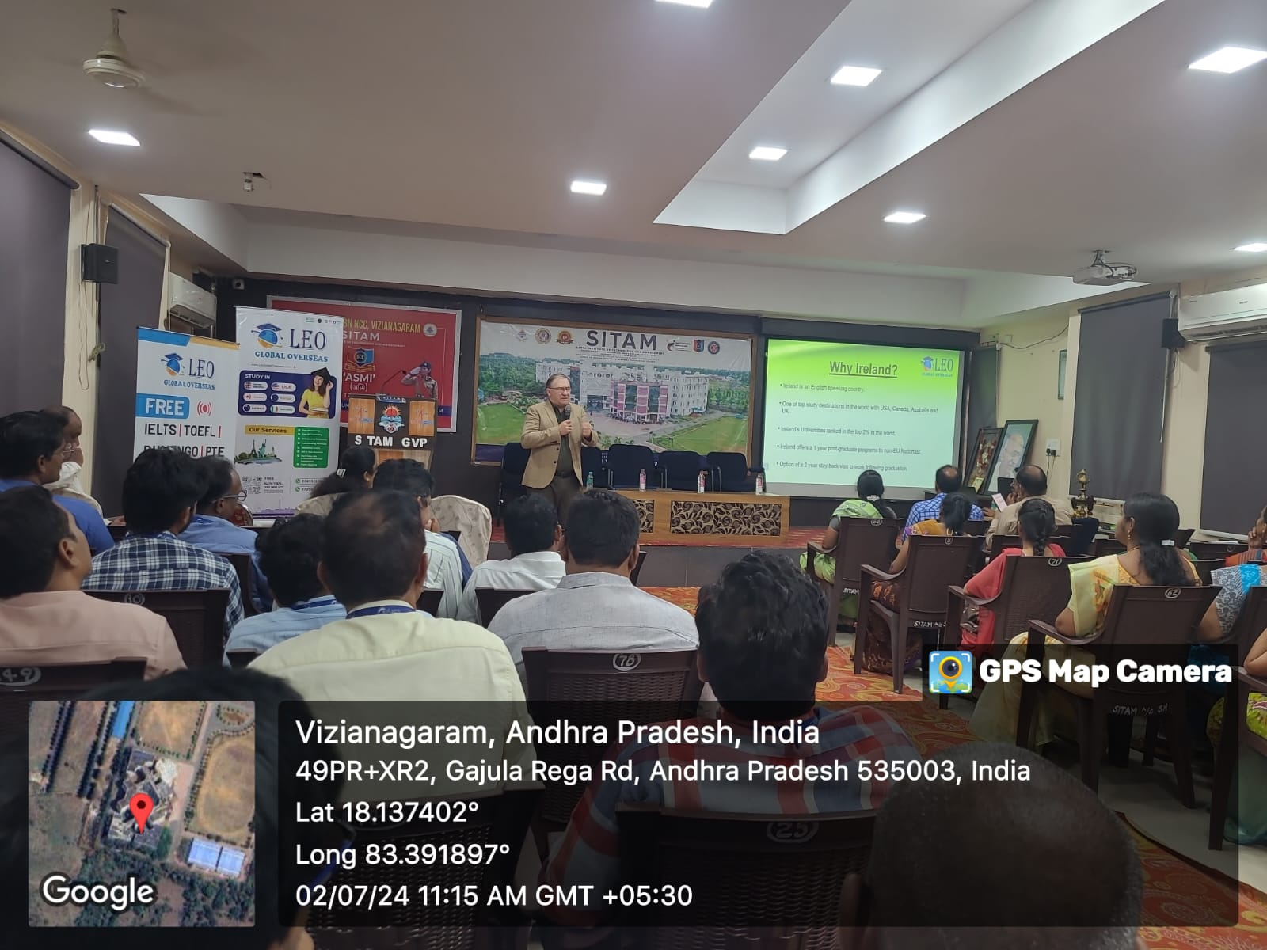
SEMINAR HALL F 202

